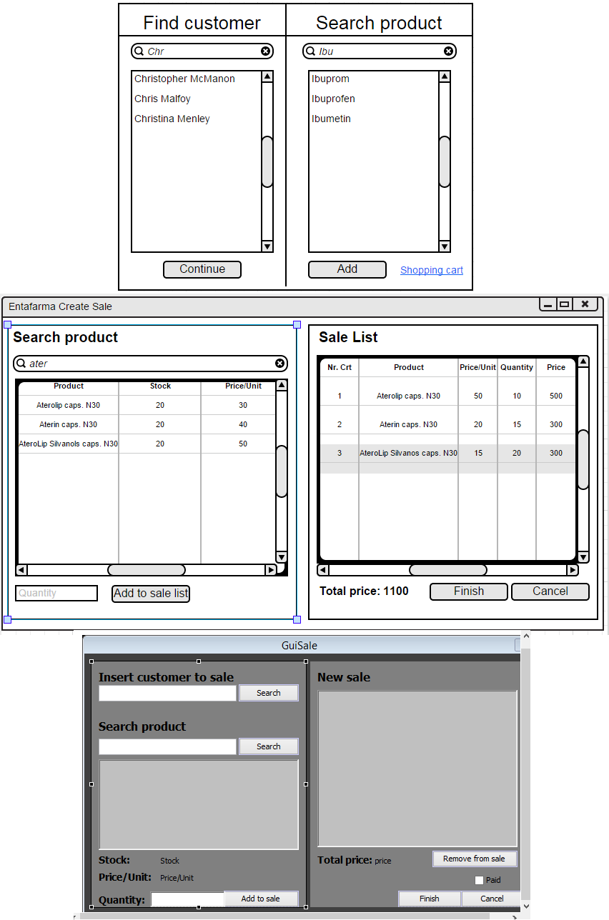**SaleGUI Progress**

The final version of sale graphical user interface. Understandable, functional, compact, easy to use and provides all the features needed.

After awhile, quite a few changes were made regarding the interface. A sale list was added so it would be possible to see what items were added to it already. Now, when searching for a product, user is able to see the stock and price of each item. In sale list the price per unit, quantity of products the customer is ordering and the total price is now provided. Finding customer was excluded for the time being.

This was the earliest mockup for the sale graphical user interface. Only the main and most important futures were added thus it looks very lackluster. At that moment it could only do two things: find the customer and add only one item at the time to the shopping cart.